Week 6

5. ReactJS-HOL

Steps :-

CohortDetails.module.css :-

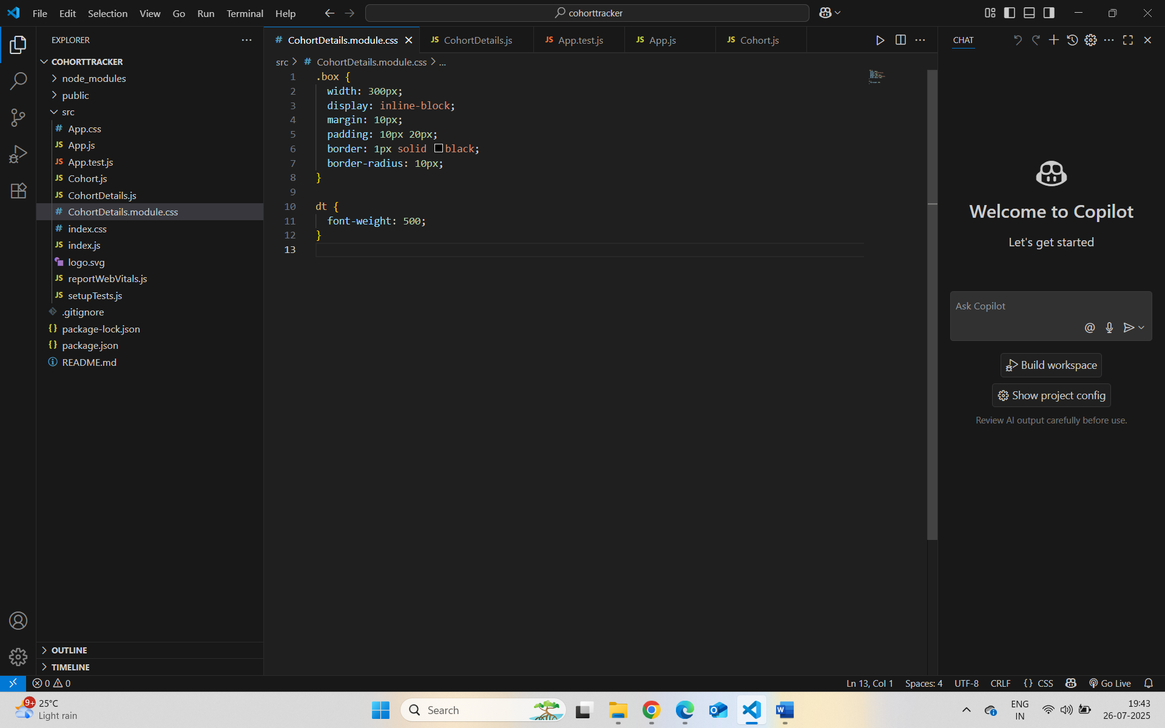

CohortDetails.js

Localhost:3000 :-

